UNV EDITORIAL CONTENT PLANNING 2023

During 2023, we will be publicizing global and regional milestones, priority partnerships and events, and marking a selection of international days with content, reflecting corporate, regional, thematic and talent acquisition priorities.

Below is a list of twelve prioritized international days, marked as “global”; this means we expect each regional office to develop at least one content piece for these days. In addition, you may wish to produce content for other international days, milestones or themes identified by your regional office as priority for your region. Plan this in advance, so we can assist from the HQ level web team.

Each regional office/section team is invited to:
- Identify international days from the below list, or add regional milestones, conferences or partnership events it wishes to prioritize publishing content for, in accordance with regional priorities, partners and volunteer deployment forecasts. This forms the basis of the communications plan for 2023.
- Map countries against these international days and the outline of the five Ps of sustainable development and the Sustainable Development Goals to ensure representation of most, if not all, countries in your region in our web editorial coverage 2023 (see table below).

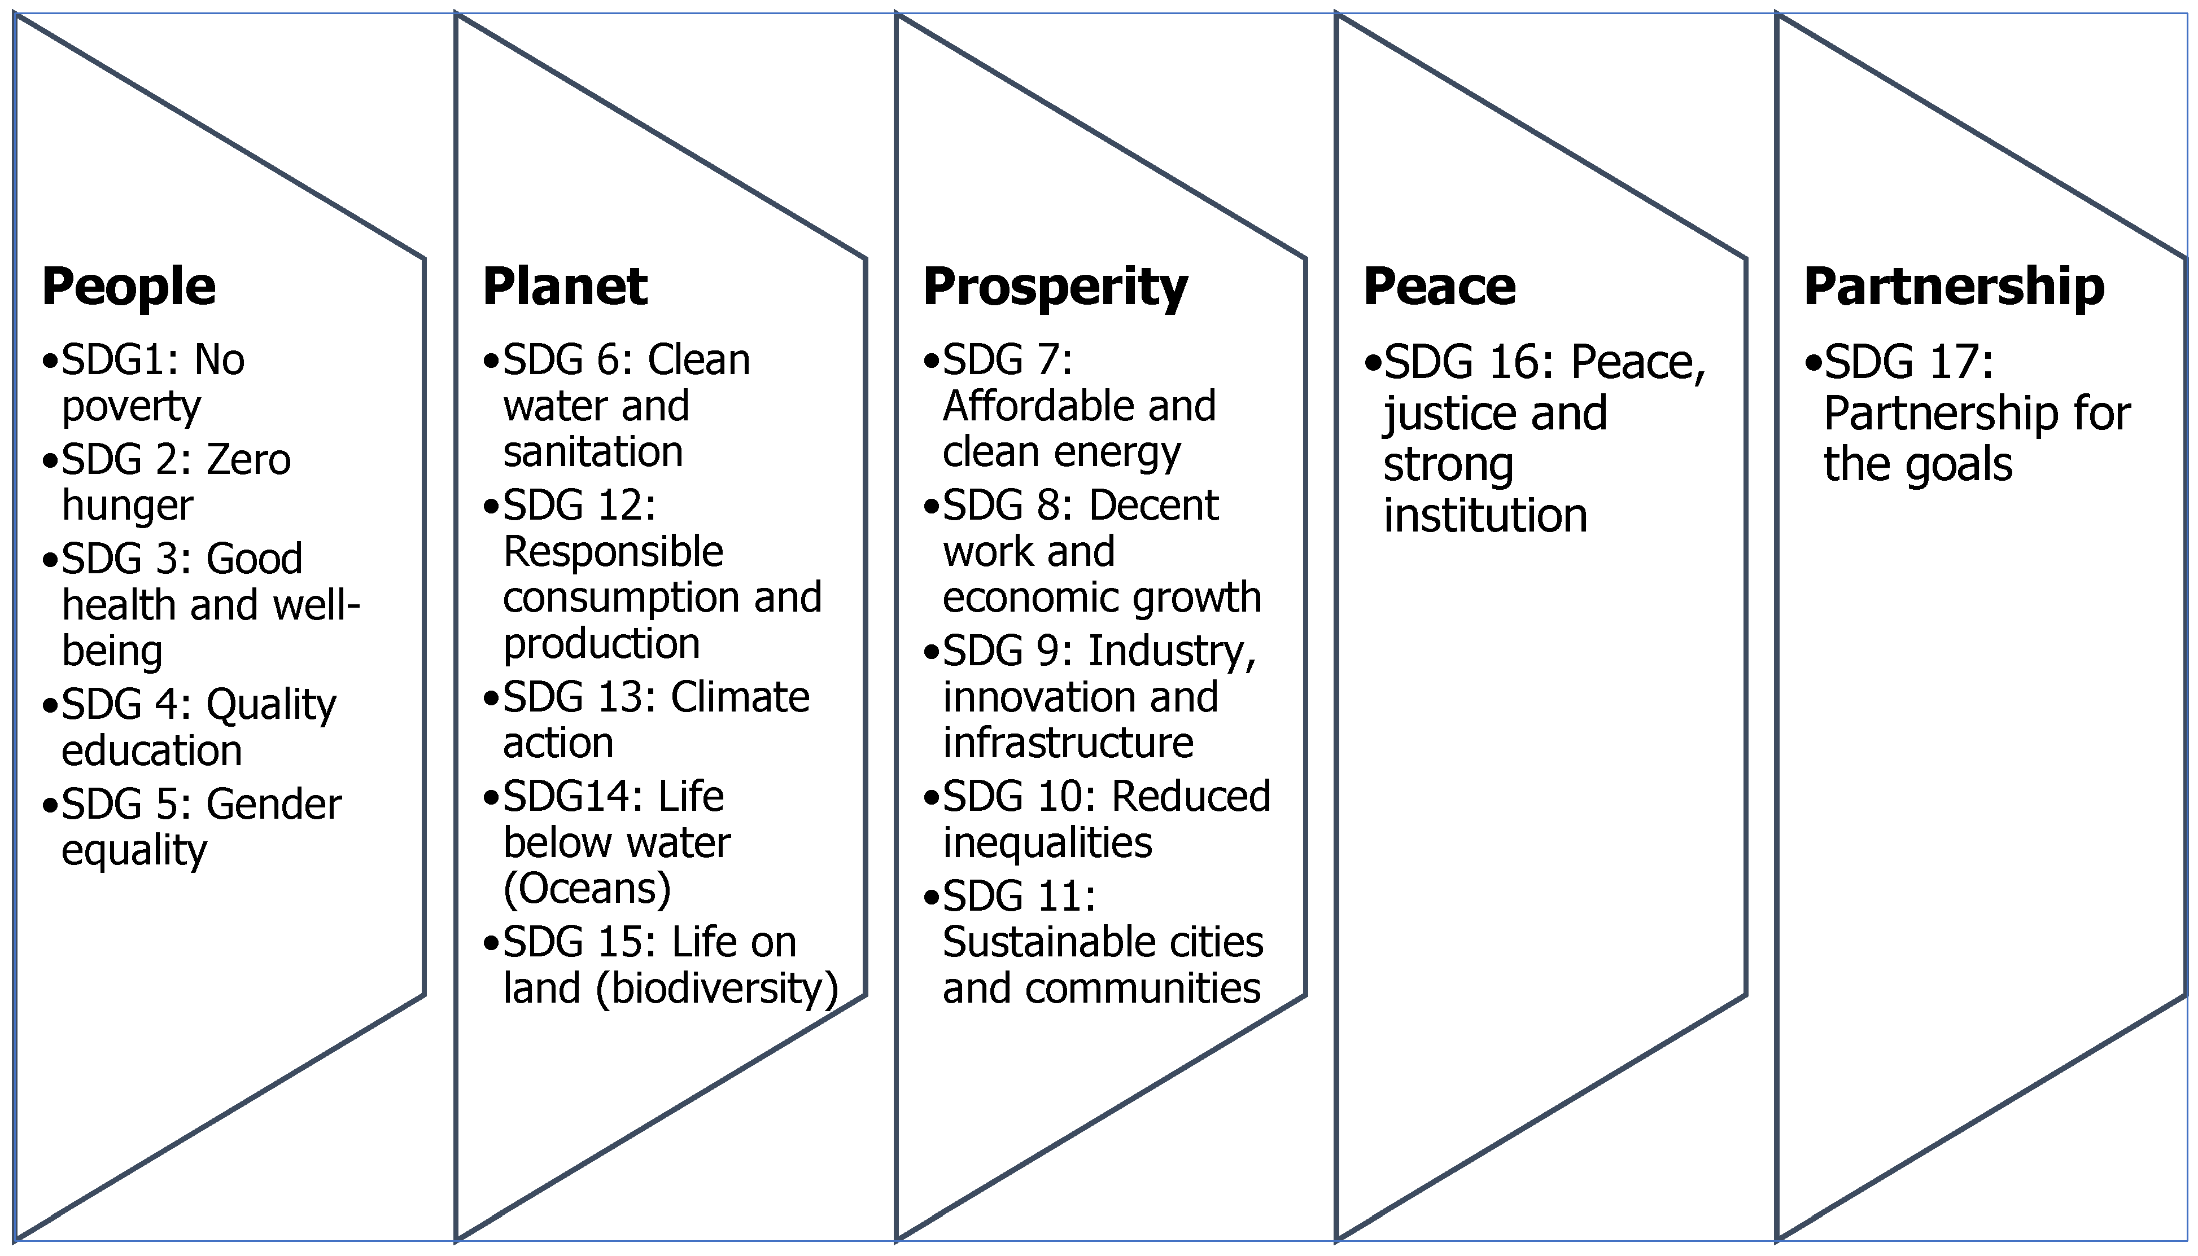
FEBRUARY
20 | International Day of Social Justice

MARCH
8 | International Woman’s Day / Global [partner focus UN Women]

APRIL
7 | World Health Day Global [partner focus WHO]

MAY
22 | International Day of Biological Diversity

29 | International Day of UN Peacekeepers / Global [partner focus UN Peacekeeping]

JUNE
5 | World Environment Day [partner focus UNEP]

20 | World Refugee Day / Global [partner focus UNHCR/IOM]

26 | International Day Against Drug Abuse and Illicit Trafficking [partner focus UNODC]

JULY
11 | World Population Day [partner focus UNFPA]

AUGUST
12 | World Youth Day / Global

19 | World Humanitarian Day / Global [partner focus OCHA/UNHCR]

SEPTEMBER
12 | International Day of South-South Cooperation [partner focus UNOSSC]

21 | International Day of Peace / Global

OCTOBER
16 & 17 | World Food Day & International Day for the Eradication of Poverty / Global [partner focus WFP]

24 | United Nations Day / Global

NOVEMBER
20 | Universal Children’s Day / [partner focus UNICEF]

25 | International Day for the Elimination of Violence against Women

DECEMBER
3 | International Day of Persons with Disabilities / Global

5 | International Volunteer Day / Global / Guidance to follow from HQ

10 | Human Rights Day [partner focus OHCHR]

27 | International Day of Epidemic Preparedness / Global

REGIONAL OFFICE MAPPING OUTLINE 2023
Instruction: please fill out the table below for your region, in collaboration with your Country Coordinators. Ensure that you plan content for all your countries, unless it is political sensitive or otherwise challenging to feature.
NB: Thank you for your input to the Content Mapping Outline 2023. I have moved to a separate file that I will share after my review. If you would like to make additions, or changes, kindly reach out to me directly. A. Said/08.02.2023

- - - - - - -

